imm cologne | Discover Interior ideas


# imm cologne - The international interiors show

The first interiors show of the year 2018 present the trends that will be shaping the

furniture and interiors sector – and the products that are good for business. At the **imm**

**cologne**, you will find a unique variety of interior design ideas for every room, every

style and every requirement – from the basics all the way to designer items and luxury

furnishings. It is only here that the international furniture business will encounter such a

range of furniture, accessories and interior design, unique anywhere in the world.

Discover the global furniture market in one place, at one time, live in Cologne!

# Why imm cologne is the place to be:

### Because here you can make the crucial step forwards.

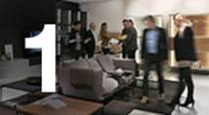

imm cologne is the perfect place to start the new season. A unique blend of the latest

trends, highly sought-after design and international business opportunities awaits you.

### Because only here you can experience the global market in

### one place.

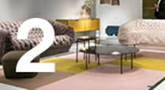

More than 1,200 exhibitors from around 50 countries will be in Cologne. You can see a

unique selection of furniture and interior design that you will not find anywhere else in

the world: from basics to luxury, from design studies to market-ready products, from

top players to the most exciting newcomers.as.

### Because here you can focus on the future and your business.

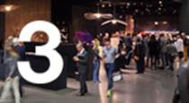

imm cologne gives your business vital momentum. Meet the key players, trendsetters

and decision makers from the global furniture industry from more than 140 countries.

### Because Cologne is where you can see design that matters.

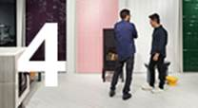

Cologne is home to excellent design: the Pure segments present the best of the best.

They showcase sensational creations by international designers and newcomers as well

as first-class concepts and solutions by leading suppliers

### Because imm cologne gives you exclusive insights into the future.

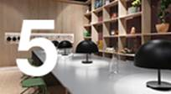

At imm cologne, formats such as “Das Haus – Interiors on Stage” and the “Pure Talents

Contest” enable you to experience at first hand the visionary ideas and concepts that will

have the entire interior design market talking in the following months.

### Because here you can learn from the best in the industry

### and their expertise.

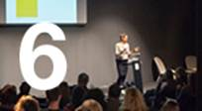

In the supporting programme of events, internationally renowned experts and designers

will give valuable insights into the design of future living spaces and the latest

developments in shapes, colours and materials.

### Because here you can discover the whole world of interior

### design.

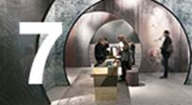

Alongside product innovations and market-ready collections, in Cologne you can find the

best solutions for bathrooms, floorings and lighting: imm cologne exhibitors will present

holistic home living concepts and innovative solutions for tomorrow’s living spaces,

spectacularly staged to inspire you.

[**www.imm-cologne.com**](http://www.imm-cologne.com)

Here you can find out all information on the fair, including:

* The 11 different Segments of exhibits
* The Hall Plan
* Search to see who is exhibiting by name, product type, country of origin etc
* You can buy tickets for the fair at discounted prices

MESSE REPS. & TRAVEL is your contact in New Zealand for **imm cologne**.

Information on trade fairs and on Cologne is available at [**www.messereps.co.nz**](http://www.messereps.co.nz/)

**Travelling to Germany?**

MESSE REPS. & TRAVEL has been handling travel and accommodation planning for

visitors to Cologne for over 25 years. Our knowledge of the hotels in Cologne, the

transport options to the fairground, the best ways to travel to and around Cologne allow

you to get the best value for your money when visiting the imm.

Maybe you want a 5 star hotel near the fair, maybe you want a smaller hotel in the

suburbs, maybe you want to stay on a hotelship moored in the city centre, maybe you

want to stay in a private apartment. We can offer you all these options.

Airfares - We know what airfare options work best for visitors to Cologne, whether it is

directly to Germany and return, or an option with further travel within Europe before or

after the fair, or maybe you want a stopover on your way to/from Europe.

Ask us for our help to find the best solution for you.

Maybe you want to combine your visit to **imm cologne** with a visit to other relevant trade

fairs such as:

* Heimtextil – International Trade Fair for Home and Contract Textiles,

9-12 January in Frankfurt

* Domotex - World of Flooring , 12-15 January in Hannover

Please contact MESSE REPS. & TRAVEL for any information on **imm cologne** or

advice and suggestions for your travel and accommodation planning.

Regards

Robert Laing

MESSE REPS. & TRAVEL

**Messe Reps. & Travel**

**4 Tokomaru St, Orakei, Auckland 1071. P O Box 26522, Epsom, Auckland 1344**

**Ph 09 5219200,**[**robert@messereps.co.nz**](mailto:robert@messereps.co.nz) **,** [**www.messereps.co.nz**](http://www.messereps.co.nz/)